ST. XAVIER’S COLLEGE

**(Affiliated to Tribhuvan University)**

Maitighar, Kathmandu



**Computer Graphics Lab Assignment #8**

**Reflection**

**Submitted by:**

Hemanchal Joshi

013BSCCSIT021

**Submitted to:**

|  |  |
| --- | --- |
| **Er. Anil Sah**  **Lecturer Department of Computer Science** |  |

**Date of Submission: September 8, 2015**

**WRITE A PROGRAM TO ILLUSTRATE THE PROCESS OF REFLECTION ALONG ORIGIN, X-AXIS AND Y-AXIS**

**SOURCE CODE:**

//---------------------------------------------------------------------------

#include <vcl\vcl.h>

#pragma hdrstop

#include "reflect.h"

//---------------------------------------------------------------------------

#pragma resource "*.dfm"

TForm1 *Form1;

int x,y,a,b,i,j;

//---------------------------------------------------------------------------

__fastcall TForm1::TForm1(TComponent* Owner)

: TForm(Owner)

{

}

//---------------------------------------------------------------------------

void __fastcall TForm1::Button1Click(TObject *Sender)

{

x=Image1->Height;

y=Image1->Width;

for (i=0;i<=x;i++)

{

for (j=0;j<=y;j++)

{

a=i;

b=-j;

b=b+y;

Image2->Canvas->Pixels[a][b]=Image1->Canvas->Pixels[i][j];

}

}

}

//---------------------------------------------------------------------------

void __fastcall TForm1::Button2Click(TObject *Sender)

{

x=Image1->Height;

y=Image1->Width;

for (i=0;i<=x;i++)

{

for (j=0;j<=y;j++)

{

a=-i;

b=j;

a=a+x;

Image2->Canvas->Pixels[a][b]=Image1->Canvas->Pixels[i][j];

}

}

}

//---------------------------------------------------------------------------

void __fastcall TForm1::Button3Click(TObject *Sender)

{

x=Image1->Height;

y=Image1->Width;

for (i=0;i<=x;i++)

{

for (j=0;j<=y;j++)

{

a=-i;

b=-j;

a=a+x;

b=b+y;

Image2->Canvas->Pixels[a][b]=Image1->Canvas->Pixels[i][j];

}

}

}

//---------------------------------------------------------------------------

**OUTPUT SCREEN:**

1. **ALONG ORIGIN**

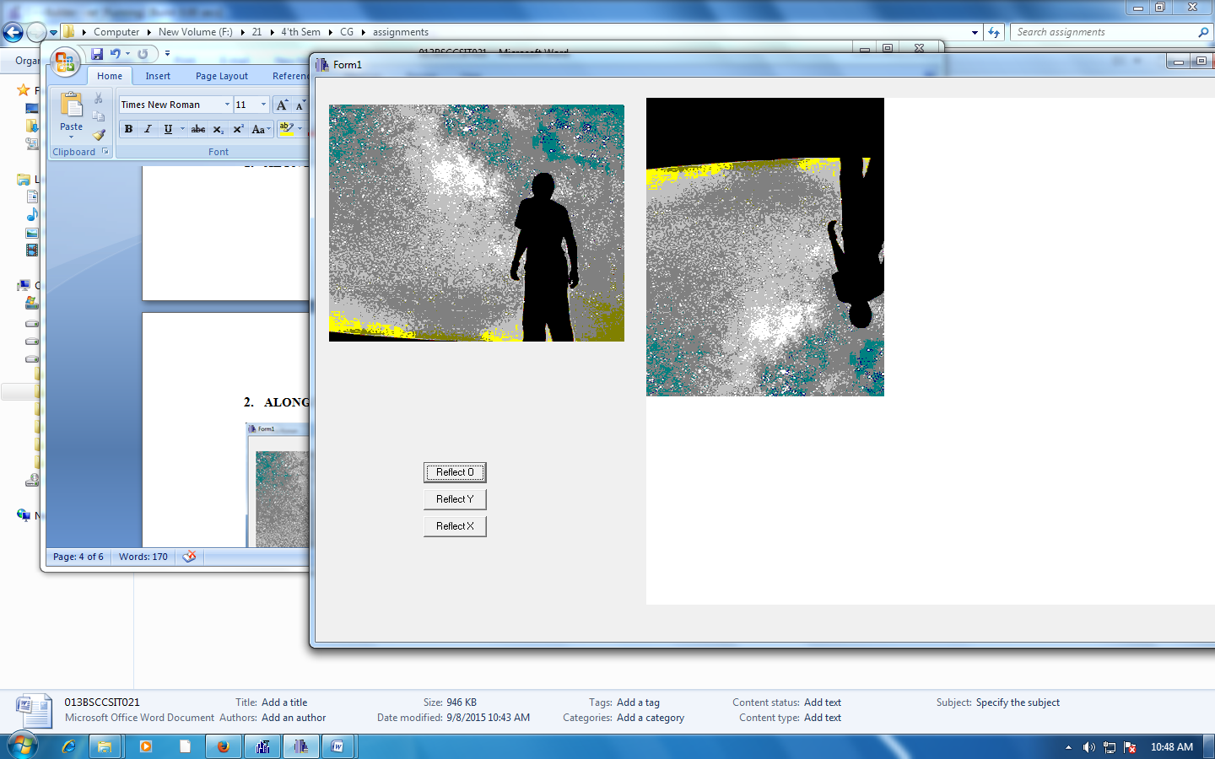

1. **ALONG X-AXIS**

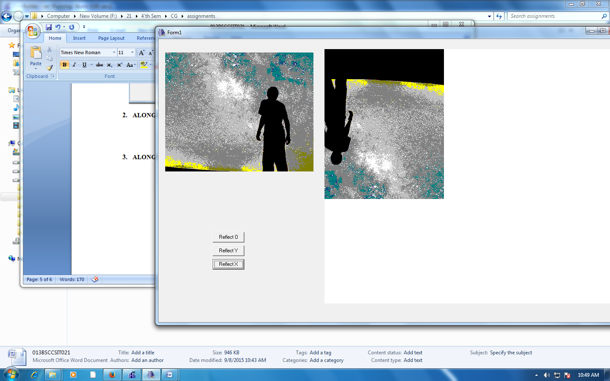

1. **ALONG Y-AXIS**

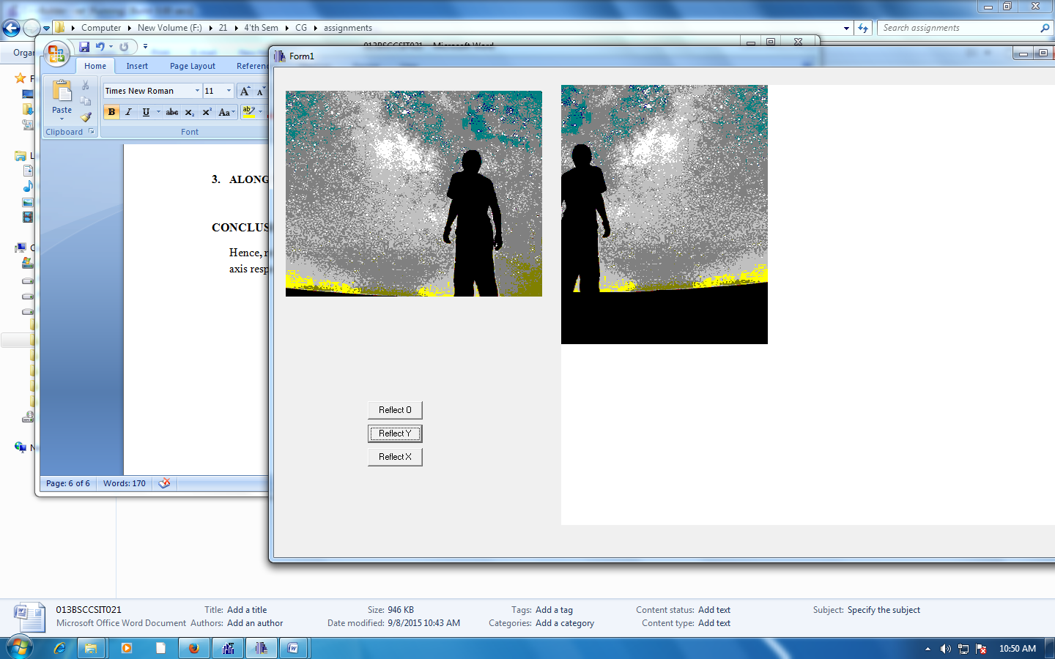

**CONCLUSION:**

Hence**,** reflection was conducted with respect to the origin as well as the y-axis and x- axis respectively.